**// STRING BASED TASK -> 5 //**

**1. Write a program in java to find the largest and smallest word in a**

**string.**

**Test Data :**

**Input the string : It is a string with smallest and largest word.**

**Expected Output :**

**The largest word is &#39;smallest&#39;**

**and the smallest word is &#39;a&#39;**

**// SOURCE CODE**

public class LargestSmallestWord {

public static void main(String[] args) {

String input = "It is a string with smallest and largest word";

String[] words = input.split(" ");

String smallest = words[0], largest = words[0];

for (String word : words) {

if (word.length() > largest.length()) {

largest = word;

}

if (word.length() < smallest.length()) {

smallest = word;

}

}

System.out.println("The largest word is '" + largest + "'");

System.out.println("The smallest word is '" + smallest + "'");

}

}

// OUTPUT :

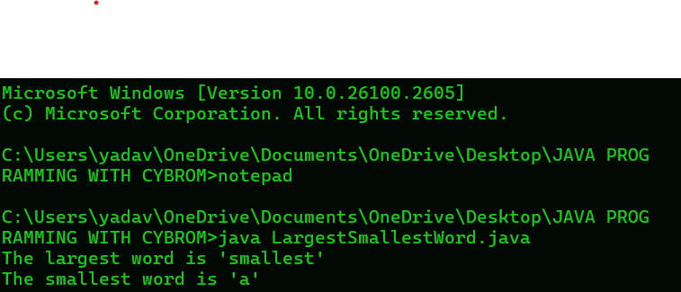

**2.  Write a program in java to convert a string to uppercase without using**

**pre-defined function**

**Test Data :**

**Input a string in lowercase : the quick brown fox jumps over the lazy dog**

**Expected Output :**

**Here is the above string in UPPERCASE :**

**THE QUICK BROWN FOX JUMPS OVER THE LAZY DOG.**

**// SOURCE CODE**

public class StringToUppercase {

public static void main(String[] args) {

String input = "the quick brown fox jumps over the lazy dog";

String uppercase = "";

for (int i = 0; i < input.length(); i++) {

char ch = input.charAt(i);

if (ch >= 'a' && ch <= 'z') {

uppercase += (char) (ch - 32);

} else {

uppercase += ch;

}

}

System.out.println("Here is the above string in UPPERCASE:");

System.out.println(uppercase);

}

}

// OUTPUT:

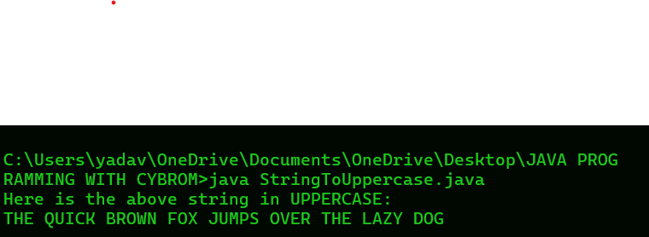

**3. Write a program in java to convert a string to lowercase without using**

**pre-defined function**

**Test Data :**

**Input a string in UPPERCASE : THE QUICK BROWN FOX JUMPS**

**OVER THE LAZY DOG.**

**Expected Output :**

**Here is the above string in lowercase :**

**the quick brown fox jumps over the lazy dog.**

**// SOURCE CODE**

public class StringToLowercase {

public static void main(String[] args) {

String input = "THE QUICK BROWN FOX JUMPS OVER THE LAZY DOG.";

String lowercase = "";

for (int i = 0; i < input.length(); i++) {

char ch = input.charAt(i);

if (ch >= 'A' && ch <= 'Z') {

lowercase += (char) (ch + 32);

} else {

lowercase += ch;

}

}

System.out.println("Here is the above string in lowercase:");

System.out.println(lowercase);

}

}

// OUTPUT:

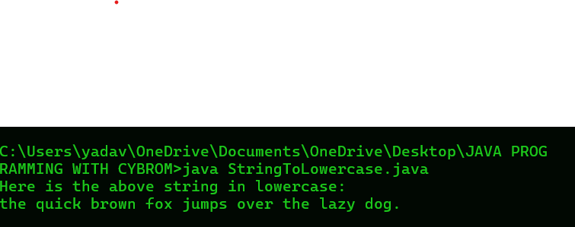

**4. Write a program in java to replace the spaces of a string with a specific**

**Character.**

**Test Data :**

**Input a string :Be glad to see the back of**

**Input replace character : \***

**Expected Output :**

**After replacing the space with * the new string is :**

**Be*glad*to*see*the*back*of\***

**// SOURCE CODE**

public class ReplaceSpaces {

public static void main(String[] args) {

String input = "Be glad to see the back of";

char replaceChar = '*';

String result = "";

for (int i = 0; i < input.length(); i++) {

char ch = input.charAt(i);

if (ch == ' ') {

result += replaceChar;

} else {

result += ch;

}

}

System.out.println("After replacing the space with '" + replaceChar + "' the new string is:");

System.out.println(result);

}

}

// OUTPUT: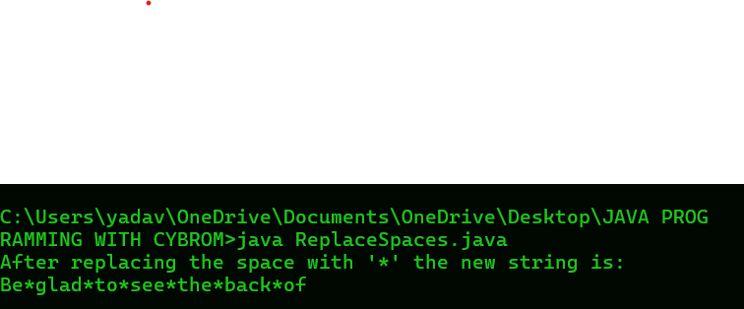

**5.  Write a program in java to split string by space into words.**

**Test Data :**

**Input a string : this is a test string**

**Expected Output :**

**Strings or words after split by space are :**

**this**

**is**

**a**

**test**

**string**

**//SOURCE CODE**

import java.util.Scanner;

public class SplitStringBySpace {

public static void main(String[] args) {

Scanner scanner = new Scanner(System.in);

System.out.print("Input a string: ");

String input = scanner.nextLine();

String[] words = input.split(" ");

System.out.println("Strings or words after split by space are:");

for (String word : words) {

System.out.println(word);

}

}

}

// OUTPUT:

